* **Titanic Survival Prediction-Logistic Regression**

1. **Import libraries**: Pandas
2. **Load and explore the data:**

Load Data:- url = 'E:/titanic_survival/tested.csv'

Read Data :- tested.csv

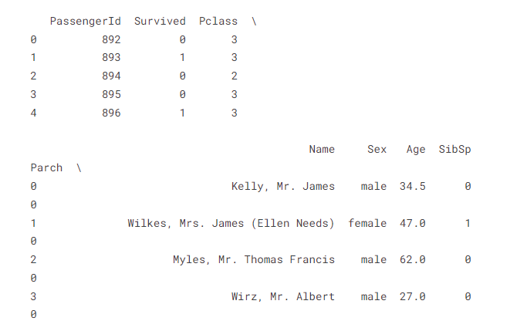

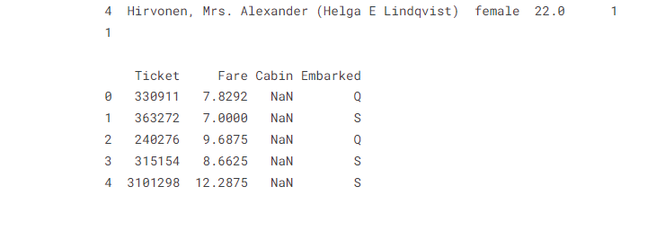

**3.Data Pre-processing:-**

* Prediction:- How many have survived.
* Features/attributes

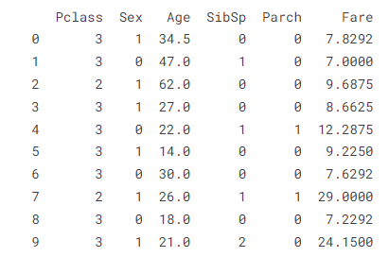

**4. Split data into training and testing data:-**

* Training = 80% from original data
* Test = 20% from original data

**5. Model building: -**

* Model used :- Logistic Regression

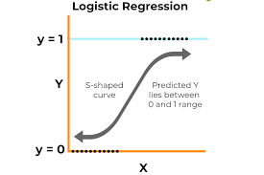

**5. Prediction of evaluation of model** = 98%

**6. plotting Confusion matrix:-**

